Linux skill exam

**Question 1**

Ls /etc

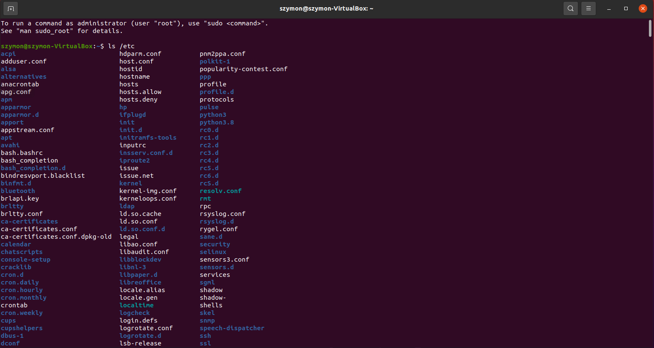

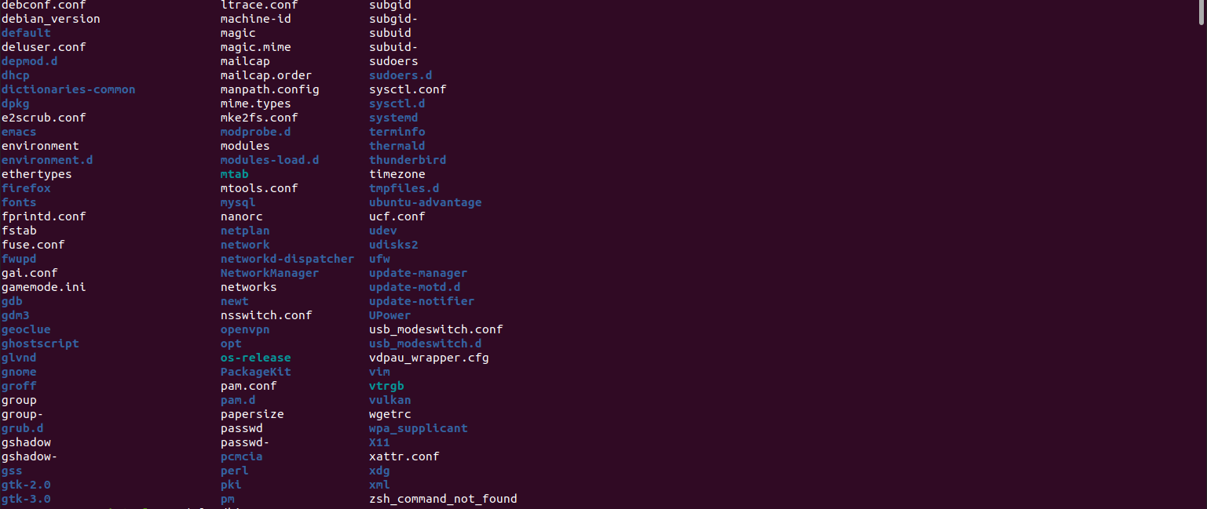

The out put of the list is above

Ls /bin

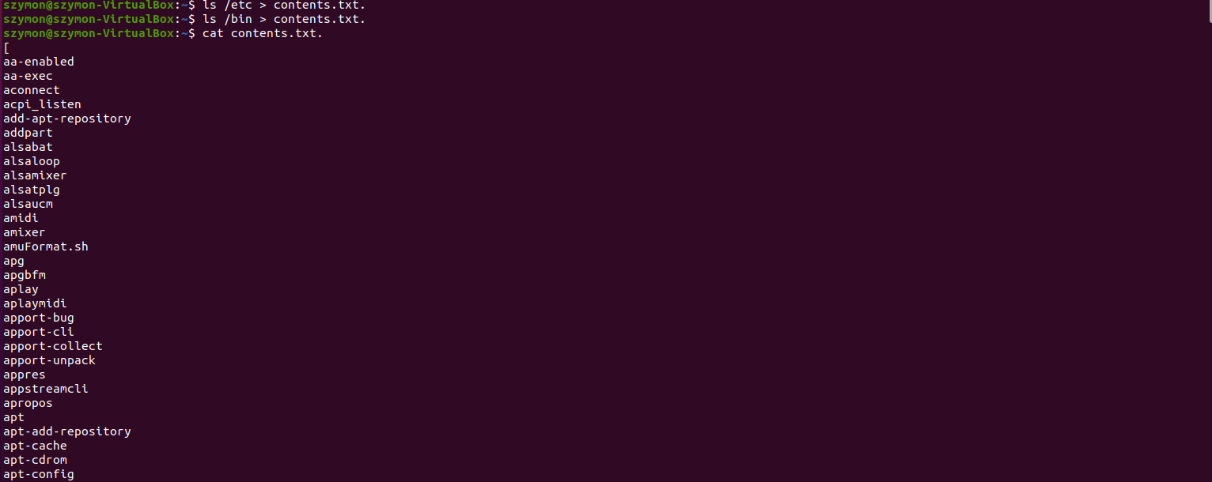

**Redirecting** the output into the file

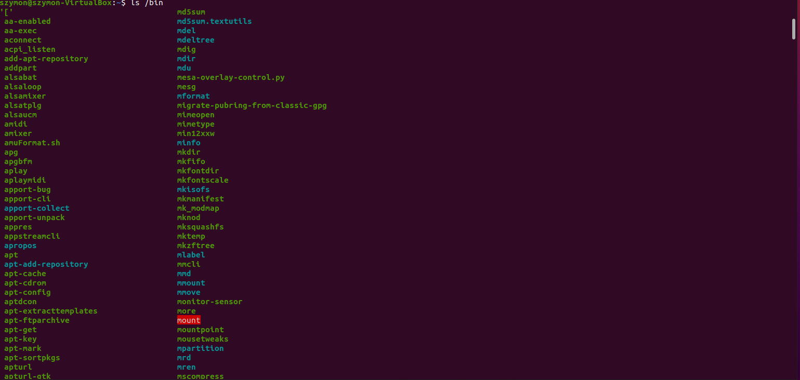

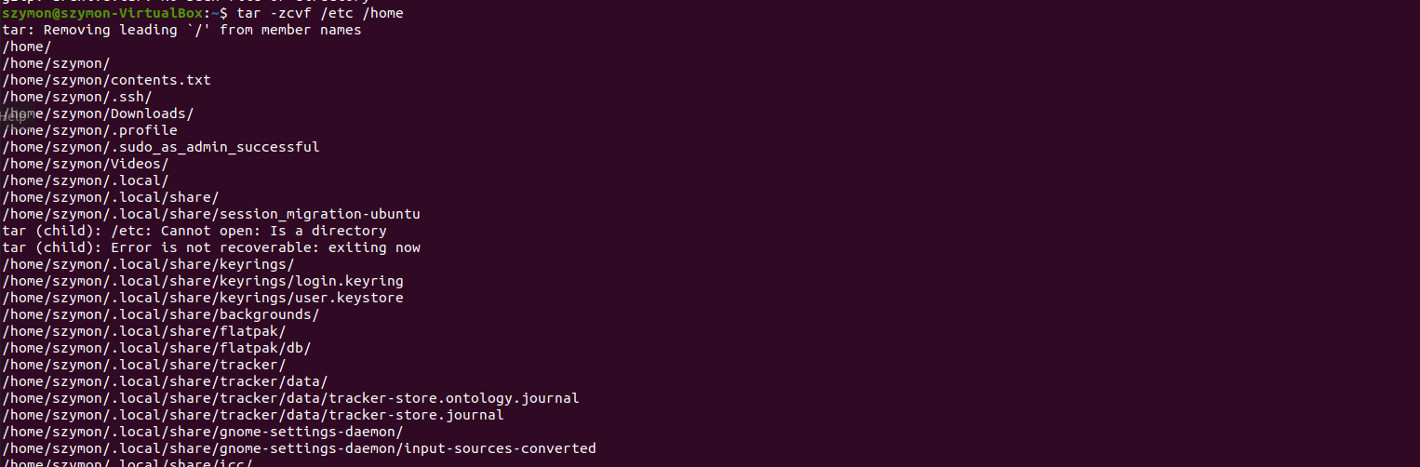

Compressing etc to home directory

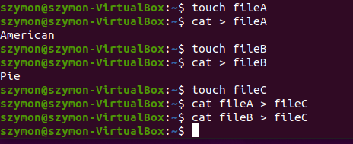

Creating fileA fileB with content and than redirecting output to fileC

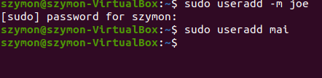

Adding two users one with home directory which is joe

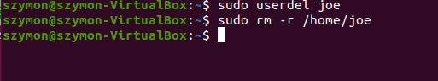

Deleting user joe and his home directory

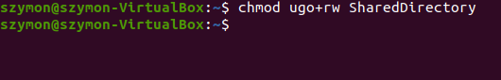

Allowing all users to read and write in the named directory



Pid of cron

Using the top command here are the nice values and pr values



To stop cron process use service crond stop

To check the current status use the ps command

Service crond start process

To find the list of all your previous commands will be in bash_history in home directory

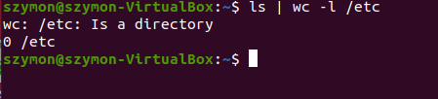

Number of files in directory

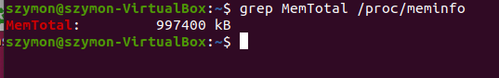

Number of memory available

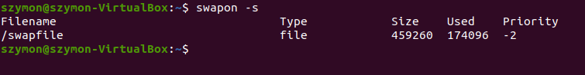

Swap partition size

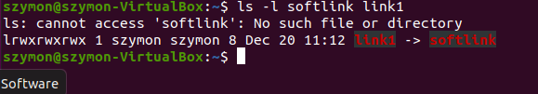

Creating soft link

**Question 3**

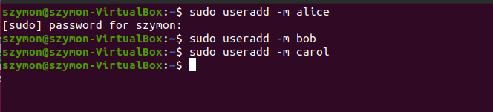

Adding the users with home directories

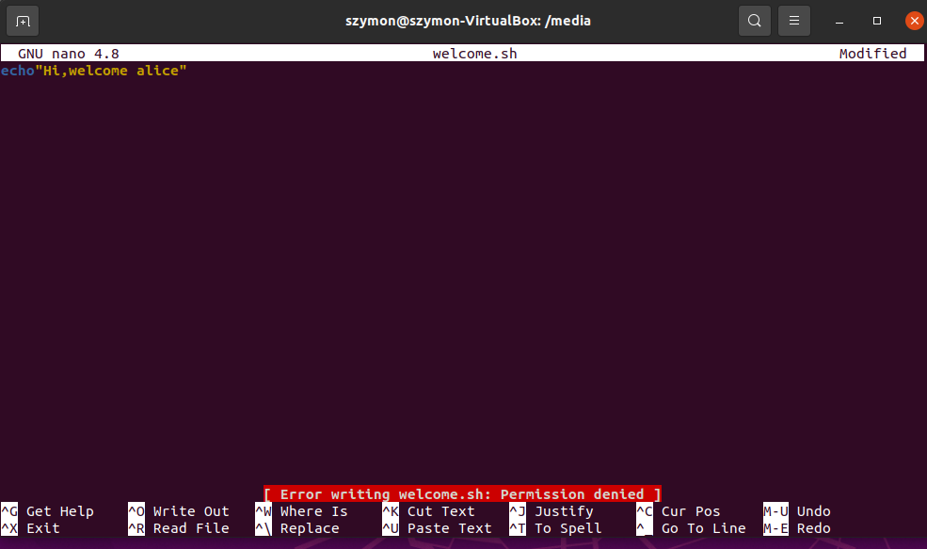

Welcoming message

Creating groups



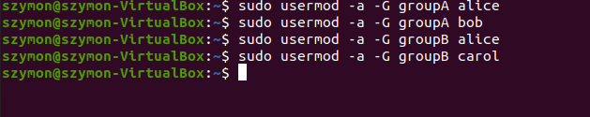

Adding users to groups